On the 28th of August there was held an ordinary Network Meeting in the Norwegian-Russian Chamber of Commerce. The meeting was held in Oslo in the facilities of the Embassy of the Russian Federation and was attended by 50 representatives of Norwegian and Russian companies.
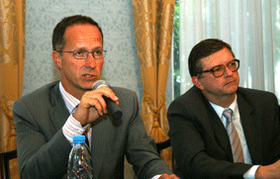 | 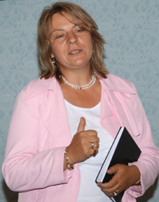 | 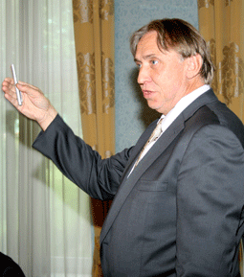
Chairman of the NRCC Thomas G Michelet (l) and Ambassador of the Russian Federation to Norway Sergey Andreev | Chair of the NRCC Cultural Commitee Irina Nikolskaia Roddvik | Managing Director of the NRCC Jarle Forbord

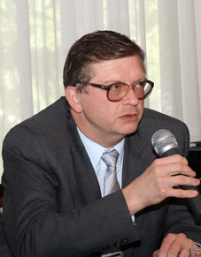 | 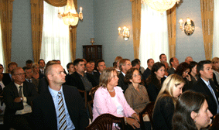 | 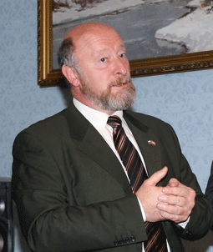
H.E.Ambassador Sergey Andreev | Participants of the NRCC Network Meeting | Head of NRCC Moscow Office Vladimir Bagreev
H.E.Ambassador of the Russian Federation to Norway Mr Sergey Andreev gave a brief introduction to the present status of the economy of the Russian Federation as well as situation in the Norwegian-Russian relations.
Mr Andreev also expressed his views on insufficient coverage of development in Russia by the Norwegian mass media which is often focused on the negative events in the neighbouring country influencing the opinion of the Norwegian people in general and Norwegian businesses specifically. He stressed out that one should also keep political and economic issues separately, also having in mind that the present state of things in Russia reflects the challenges the country is facing at the moment.
The meeting was continued by the presentation of Nizhny Novgorod County given by the Head of NRCC Moscow Office Mr Vladimir Bagreev who have recently visited this area, also in connection with the preparations of the new Norwegian business mission. As informed earlier, this region was chosen as the new destination for the Norwegian business mission to be organised this fall by NRCC in cooperation with the Norwegian Embassy in Moscow. Nizhny Novgorod is a region with fast-developing economy, high IT-potential and well-developed manufacture and processing industries. The NRCC will distribute more information about the planned business mission later.
Information Adviser of the NRCC Katerina Smetanina informed the audience about two of the NRCC projects which should give NRCC members and other companies better opportunities for doing business in Russia and Norway. The first project, Norwegian-Russian Business Journal, was started in May this year when the first issue of the Journal was produced and distributed in several hundreds copies to the relevant market players and authorities in Norway and Russia. Basing on positive feedback from the recipients, it is decided to broaden the scope of the project by increasing the circulation, the number of pages and introduce advertising possibilities with solid member discounts.
The second project which is being launched in these days is Russia Business Directory which should serve as one-stop-guide to Russia for newcomers and experienced players in Norway. The ambition is to collect information about most relevant issues in one place and keep it up-to-date and relevant.
The next speaker, Vice President External Affairs, Central/Eastern Europe, Telenor and Chair of the NRCC Cultural Committee Irina Nikolskaia Roddvik gave a short summary of the cultural events coming later this year.
At the end of the meeting Managing Director of NRCC Jarle Forbord informed the participants about the coming events in the NRCC.
Presentations from the Network Meeting will be posted on our web in the coming days (only for NRCC members)

